Lab11: Structures

Objective(s):
- To be able to use Structures

Exercises

Exercise 1
Write a structure named triangle which has 3 points p1 , p2 and p3, program takes input and determines if it is a right-angle or not.
Note: A right triangle is triangle with an angle of 90 degree. The sides a, b , and c of such a triangle satisfy the Pythagorean theorem.
c² = a² +b²

#include<iostream>
#include<cmath>
using namespace std;

struct triangle
{
double a, b, c;
};

int main() {
triangle t;

cout << " enter the value for side a " << endl;
cin >> t.a;

cout << " enter the value for side b " << endl;
cin >> t.b;

cout << "enter the value for side c " << endl;
cin >> t.c;
if (pow(t.a,2)==(pow(t.b,2) + (pow(t.c,2))))
{
cout<<"it is a right angles triangle"<<endl;
}
else
{
cout<<"it is not a right angled triangle"<<endl;

}
system("pause");
return 0;
}

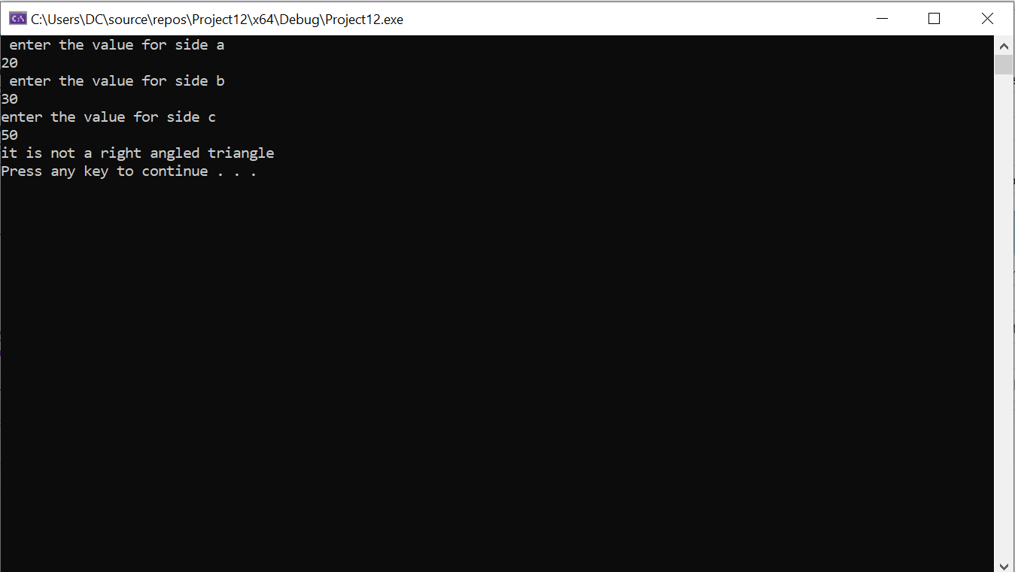
Exercise 2
Make a structure BookRec which stores the following details of a book: title of the book. Author’s name , it’s publisher and price .Write a program to take input of 3 books and display it on console.
Example:
Title: Starting Out with C++
Author: Addison Wesley
Publisher: Tony Gaddis
Price: $150.00
Exercise 3
Create a structure employee to keep record of the name, employee number, salary and designation of the employee, Input data of 3 employees and print them respectively by using function.

